Eventi
Use Case Specification

Submitted to:

Asst. Prof. Ma. Rowena C. Solamo
Faculty Member
Department of Computer Science
College of Engineering
University of the Philippines, Diliman

Submitted by:
Dimaano, Aaron Diego I.
Lopez, Matthew S.
Torres, Jacob Angelo V.

In partial fulfillment of academic requirements
for the course
CS 191 Software Engineering I
of the
1st Semester, AY 2015-2016
Unique Reference:
The documents are stored in https://github.com/Tom-2013-06417/CS191-192_Event_Sharing/tree/master/02-Requirements%20Engineering.
Link to this document: https://github.com/Tom-2013-06417/CS191-192_Event_Sharing/blob/master/02-Requirements%20Engineering/9.0%20-%20Upload%20event.pdf.

Document Purpose:
The purpose of this document is to exhaust the step-by-step process of the Use Cases in every scenario possible.

Target Audience:
To our project client and adviser, our fellow 191 classmates, and our future selves when they need to refer back to this document.

Revision Control:

Revision Date | Person Responsible | Version  Number | Modification
09/18/15 | Lopez, Matthew | 1.0 | Initial Document
09/25/15 | Torres, Jacob Angelo | 1.1 | Edited the post-conditions

Use-Case Name: Upload event

Description: A core functionality of the site. This feature allows users to upload their events to the site for all users to see. This action requires the user to be part of an organization, since an event is going to be attributed to an organization.

Preconditions: There is an internet connection to the Eventi server and a device with browsing capabilities. A registered user that has permission to operate an organization must be currently logged into the site.

Flow of Events:

Scenario Name | Description
Scenario 1 (Basic Flow)  Upload event with  valid details | 1. Registered User chooses to upload a new event of the Organization  2. Registered User is prompted by the System to provide the event’s details  3. Registered User provides the details of the event  4. If System accepts the details provided by the RU for the event, then the event shall be uploaded
Scenario 2  Upload event with  invalid details | 1. Registered User chooses to upload a new event of the Organization  2. Registered User is prompted by the System to provide the event’s details  3. Registered User provides the details of the event  4. If the Registered User provided invalid and/or incomplete details for the event, then the System will ask for details until the details given are valid (or until the Registered User presses cancel)
Scenario 3  Cancel event upload | 1. Registered User chooses to upload a new event of the Organization  2. Registered User is prompted by the System to provide the event’s details  3. Registered User provides the details of the event  4. If the Registered User provided invalid and/or incomplete details for the event, then the System will ask for details until the Registered User presses cancel (or until the Registered User provides valid details)

Activity Diagram of the Flow of Events:

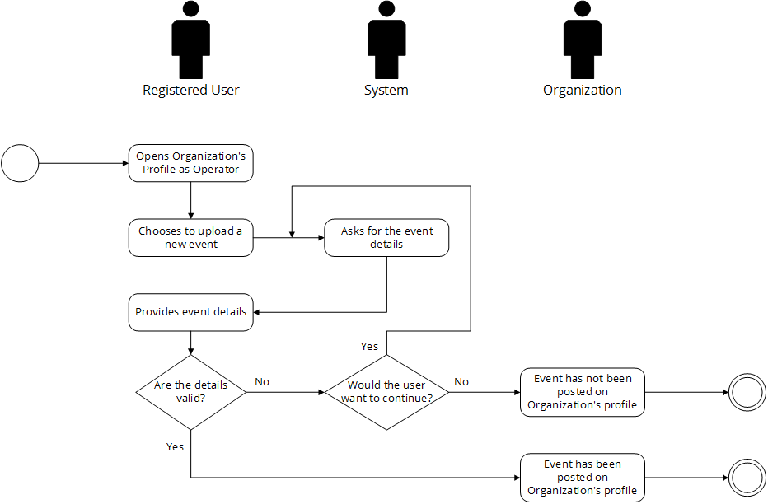

Post-conditions: NONE

Special Requirements: NONE

